AI Legal Argument Generator
Leverage Past Case Law for Intelligent Legal Argument
Prof. Sagar Janokar
Vishwakarma Institute of Technology Pune
Vishwakarma Institute of Technology Pune
Pune, Maharashtra, India
sagar.janokar@vit.edu
Rohan Sharma
Vishwakarma Institute of Technology Pune
Vishwakarma Institute of Technology Pune
Pune, Maharashtra, India
rohan.sharma24@vit.edu
Aaryan Shelar
Vishwakarma Institute of Technology Pune
Vishwakarma Institute of Technology Pune
Pune, Maharashtra, India aaryan.shelar24@vit.edu
Arya Shedge
Vishwakarma Institute of Technology Pune
Vishwakarma Institute of Technology Pune
Pune, Maharashtra, India
arya.shedge24@vit.edu

Abstract—Legal practitioners often face challenges in retrieving relevant case precedents and crafting effective arguments under tight time constraints. This paper proposes an AI-powered legal assistant designed to automate two critical components of legal reasoning: retrieval of similar past judgments and generation of strategic legal advice tailored to the current case. The system employs a multi-stage pipeline involving web scraping of Bombay High Court judgments, structuring data using large language models (LLMs), storing the results in a NoSQL database, and embedding the cases into a vector space for semantic similarity retrieval. Once relevant cases are retrieved, GPT-based models analyze the context and generate personalized legal strategies, including common pitfalls, recommended legal clauses, and argumentation techniques. Our implementation demonstrates how AI can significantly augment legal workflows by reducing research effort and improving argument precision. The paper also discusses current limitations, such as dataset constraints and jurisdictional generalization, while proposing future directions for real-time integration, multilingual support, and legal simulation.
Keywords—Legal AI, Precedent Analysis, NLP in Law, IRAC Framework,Legal Reasoning,Judicial Decision Support
1.INTRODUCTION
In the Indian legal ecosystem, case law plays a pivotal role in shaping legal arguments and judicial outcomes. Lawyers, especially those practicing in High Courts like the Bombay High Court, must frequently reference historical judgments to support their arguments. However, the manual retrieval and analysis of relevant past cases remains a time-consuming and inefficient process. Legal practitioners often rely on keyword-based searches on court websites, followed by a laborious review of lengthy documents. This workflow, while common, is not scalable—particularly for junior lawyers or those handling a high volume of cases.
With the recent advances in artificial intelligence, there is growing potential to automate and enhance this process. Modern Natural Language Processing (NLP) models can extract structured information from unstructured legal texts, identify semantic similarities between cases, and even generate tailored insights [1], [2]. These capabilities are especially beneficial in jurisdictions like India, where judgments are rich in legal reasoning but are often inconsistently formatted or difficult to parse using traditional methods [3].
To address this challenge, we propose a two-part AI-driven legal assistant. First, our system retrieves semantically similar judgments from a curated legal corpus using vector embeddings and dense similarity search. Second, it employs generative language models to produce personalized legal strategies, including key precedents, frequently overlooked arguments, and applicable clauses. By automating both retrieval and strategic insight generation, this system empowers lawyers to make more informed decisions faster and with greater confidence.
Our work draws inspiration from global developments in Retrieval-Augmented Generation (RAG) [4], legal-specific transformer models such as Legal-BERT [5] and CaseLawBERT [6], and ongoing efforts in legal AI benchmarking such as COLIEE [7]. We demonstrate our system using scraped judgments from the Bombay High Court and show how it can be a valuable assistant for real-world litigation workflows.

2.RELATED WORK
Significant progress has been made at the intersection of legal informatics and deep learning. Foundational work by Lewis et al. introduced Retrieval-Augmented Generation (RAG), a framework that combines dense retrieval with transformer-based generation to handle knowledge-intensive NLP tasks [4]. RAG-like architectures are particularly well-suited to the legal domain, where answers often depend on retrieving relevant precedents and synthesizing reasoning from multiple documents.
In the legal space, transformer models fine-tuned on law-specific corpora have become instrumental. Legal-BERT [5] and CaseLawBERT [6] are pre-trained using datasets of statutes, case law, and legal commentary, enabling better semantic understanding compared to general-purpose BERT models. These models have shown strong performance in tasks like legal judgment prediction, statute classification, and retrieval [8], [9].
Several tools also focus on information extraction from raw legal documents. LexNLP, for instance, provides robust capabilities for identifying parties, dates, amounts, and citations [10], which aligns with the preprocessing pipeline used in our system. Additionally, the COLIEE (Competition on Legal Information Extraction and Entailment) benchmark has become a global standard for evaluating legal retrieval and entailment models [7].
More recent work has explored hybrid systems that integrate retrieval with generative reasoning. Kalra et al. developed HyPA-RAG, a parameter-adaptive legal assistant that dynamically adjusts retrieval depth and generation strategy based on query complexity [11]. Other domain-specific tools, such as LawPal and LegalRAG, have applied RAG-like pipelines to Indian and multilingual legal corpora, respectively, showing how these systems can be tailored to specific jurisdictions [12], [13].
Furthermore, research on summarization in legal NLP has demonstrated the usefulness of LLMs in condensing lengthy legal texts into strategic summaries. Zuo et al. used transformer-based models to extract case outcomes and legal arguments, closely aligning with our goal of providing strategic guidance to lawyers [14].
These advancements collectively validate the design of our proposed system, which leverages the strengths of vector-based retrieval, structured extraction, and generative modeling to create an end-to-end AI assistant for litigation support.

3.LITERATURE REVIEW

Artificial Intelligence (AI) has seen a significant rise in applications within the legal domain, particularly in automating tasks such as legal research, judgment prediction, summarization, and information extraction. The goal of leveraging AI in the legal profession is not to replace lawyers but to augment their capabilities, reduce cognitive load, and improve efficiency. This literature review highlights key advancements relevant to our system, focusing on legal document retrieval, semantic understanding, and AI-powered strategic assistance.
Early studies such as Zhong et al. and Luo et al. demonstrated the potential of deep learning models in predicting legal outcomes using structured representations of case facts and law articles. These works laid the groundwork for more advanced legal language models. With the emergence of transformer architectures, Chalkidis et al. proposed Legal-BERT and CaseLawBERT , both of which were fine-tuned specifically on legal corpora. These models significantly outperformed generic BERT models in tasks such as statute classification and case similarity retrieval. Their work emphasized the importance of domain-specific pretraining in the legal NLP space.
Simultaneously, the Retrieval-Augmented Generation (RAG) framework introduced by Lewis et al. bridged the gap between document retrieval and text generation. This model architecture is particularly powerful in knowledge-intensive tasks where answers must be grounded in external documents. Our system builds upon this architecture by retrieving legal judgments similar to the input case and generating strategic suggestions tailored to the new context.
The COLIEE competition provides a global benchmark for evaluating legal case retrieval, entailment, and statute interpretation systems. Participating systems have incorporated dense embedding techniques, hybrid retrieval mechanisms, and entailment classifiers to simulate tasks akin to real-world legal research. These developments help validate the effectiveness of our system’s retrieval pipeline, which also uses embedding-based semantic search.
Information extraction remains a critical component of automating legal workflows. The LexNLP library [10] enables rule-based and ML-assisted extraction of structured entities such as parties, dates, verdicts, and monetary amounts. However, traditional extraction methods often falter when applied to inconsistently formatted or verbose Indian judgments. Recent work has explored using Large Language Models (LLMs) for zero-shot or few-shot extraction, showing improved generalization across document types [2], [12].
Further advancements include hybrid AI systems that adaptively balance retrieval and generation, such as HyPA-RAG[11]. These systems dynamically allocate computational resources based on query complexity and document length, an approach beneficial in processing lengthy court judgments. Other tools like LawPal [12] and LegalRAG [13] demonstrate the viability of legal assistants for Indian and multilingual legal systems. These studies underline the necessity of localized training data and jurisdiction-specific fine-tuning, which we also adopt by focusing on the Bombay High Court corpus.
Summarization is another crucial task in the legal domain due to the length and verbosity of legal documents. Zuo et al.[14] applied transformer-based summarization models to extract salient legal arguments and case outcomes. Their findings support our approach of using generative models (e.g., GPT) to produce condensed, human-readable strategic reports for lawyers. Additionally, Ju [15] introduced a poly-vector retrieval approach that enhances retrieval accuracy in complex legal queries, suggesting possible improvements for future versions of our system.
Finally, broader reviews of AI in the Indian legal context, such as those by Sil et al and Chatterjee & Sreenivasulu, highlight systemic challenges—ranging from the unstructured nature of legal records to ethical and regulatory concerns. These reviews provide important socio-technical grounding for our system, which aims to enhance access to justice through responsible and interpretable AI.
In summary, the current body of research demonstrates the technical feasibility and societal relevance of AI-driven legal tools. However, there remains a need for integrated systems that combine retrieval, structured extraction, and personalized strategy generation—particularly within the context of Indian courts. Our system seeks to bridge this gap.

4.METHODOLOGY
Our proposed system is designed as a two-stage AI-powered assistant to support legal professionals in retrieving relevant case law and generating personalized strategic advice. The methodology is structured around three main components: data collection and structuring, semantic case retrieval, and legal strategy generation.

4.1 Data Collection and Structuring
To construct a relevant and jurisdiction-specific corpus, we scraped publicly available legal case judgments from the Bombay High Court website. The scraping pipeline used rule-based HTML parsers combined with regular expressions to extract raw case text, organized by case number and section.
Given the unstructured nature of Indian court judgments, we employed LLM-based information extraction to derive structured attributes from each document. The extracted metadata includes: Case Title (Petitioner vs. Respondent), Date of Judgment, Legal Sections Referenced, Summary of the Case, Verdict or Outcome, Bench Composition and Court Division.
To ensure consistency, we used prompt engineering with GPT-based models to extract this data in a standardized JSON format. All structured entries were stored in a MongoDB document-oriented database, supporting flexible schema design and indexing for fast retrieval.

4.2 Semantic Vector Embedding and Case Retrieval
We adopted Legal-BERT and CaseLawBERT embedding models to represent each case document as a dense vector in semantic space. Each vector incorporates both the factual narrative and applicable legal clauses of the case.
For similarity retrieval, we used FAISS (Facebook AI Similarity Search), a high-performance vector indexing library. When a lawyer enters a new case scenario (e.g., description, parties, sections involved), the input is embedded using the same encoder and queried against the vector store to retrieve the Top-N most semantically similar cases.
This retrieval approach is inspired by the Retrieval-Augmented Generation (RAG) framework [4], where information retrieval precedes any generation task, ensuring factual grounding in known case law.

4.3 Personalized Legal Strategy Generation
Once similar cases are retrieved, the system initiates a strategic generation pipeline. This pipeline involves:Case Comparison – A GPT-based model compares the user’s case with retrieved ones, analyzing similarities and divergences in fact patterns, legal sections, and outcomes.Summarization of Past Judgments – Each retrieved judgment is condensed using abstractive summarization to highlight critical rulings, successful arguments, and judicial reasoning [14].Strategy Suggestion Generation – Based on this analysis, the model produces a natural language advisory report that includes:
Legal clauses that proved effective, Common mistakes in similar contexts, Suggested argument strategies, Warnings on sections often misapplied.
The final output is a customized legal brief, designed to augment the lawyer's own reasoning, not replace it. This aligns with human-in-the-loop design principles recommended in legal AI systems .
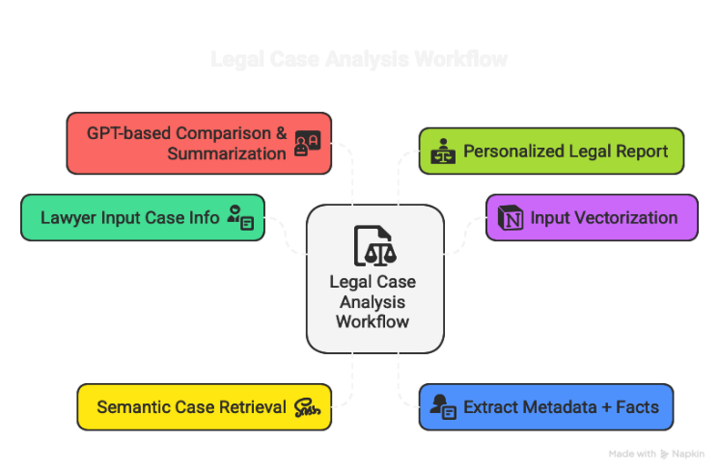
Fig 1. Workflow of the system

5.IMPLEMENTATION
The system was implemented using a modular architecture that integrates web scraping, language models, vector databases, and generative AI components. We built the entire pipeline using Python, leveraging open-source libraries for NLP, web automation, and database management. The implementation is divided into three main modules: (1) Data Acquisition & Preprocessing, (2) Retrieval Engine, and (3) Legal Strategy Generation.

5.1 Data Acquisition and Preprocessing
We developed a Python-based web scraper using requests, BeautifulSoup, and Selenium to crawl and extract judgments from the Bombay High Court website. Each scraped case was cleaned to remove boilerplate HTML content, citations, and formatting artifacts. The raw text was stored in .txt files for backup and pipeline testing.
To convert unstructured case text into structured legal documents, we used OpenAI GPT-4 through prompt-engineered API calls. A sample prompt used for extraction was:
“Extract the petitioner, respondent, date of judgment, IPC sections cited, brief summary, and final verdict from the following legal case judgment.”
The extracted data was converted into JSON and stored in MongoDB, which offers flexible indexing and allows efficient querying based on sections, parties, or verdicts.

5.2 Semantic Embedding and Retrieval Engine
We used CaseLawBERT [6] and Legal-BERT [5] to generate semantic embeddings for each structured case. The HuggingFace transformers library was used to load pretrained models and encode both case summaries and metadata into 768-dimensional vectors.
These embeddings were indexed using FAISS (Facebook AI Similarity Search), enabling fast Approximate Nearest Neighbor (ANN) search on large datasets. We configured FAISS with IndexFlatIP for inner product-based similarity search, which balances speed and accuracy for legal documents.
When a lawyer enters a new case scenario, the system performs the following:Encodes the input case into a semantic vector using the same encoder.Also queries FAISS to retrieve the Top-N most similar past cases with retrieving structured data for each matched case from MongoDB.

5.3 Legal Strategy Generation
Once relevant cases are retrieved, we use OpenAI’s GPT-4 to generate strategic guidance. The pipeline involves Case Comparison, that is the system compares the current case to each retrieved case, analyzing legal sections, verdict patterns, and argument strategies. It also summarizes GPT condenses each retrieved case into a 4–5 sentence summary using custom prompts designed for legal summarization. In strategic suggestion generation there is a final prompt synthesizes all comparisons and summaries to produce a custom strategy memo for the user.
Example output includes:“Section 420 IPC was dismissed in 3 of 5 similar cases due to lack of material evidence.”
All outputs are presented in a simple HTML dashboard built with Flask and Bootstrap, allowing users to enter cases, view retrieved judgments, and download strategy reports.

5.4 Deployment and Infrastructure
The system was deployed on a Linux-based cloud server using:
FastAPI for serving APIs , MongoDB Atlas for document storage, FAISS for local vector search, OpenAI API for GPT-4-based summarization and generation.

6.RESULTS
The proposed AI legal assistant system was tested in a real-world simulation where a user inputs a legal scenario to receive intelligent case insights, legal strategies, and relevant precedents. Below are the stepwise terminal outputs from the system execution.

6.1 User Query Input
The user initiates the system by entering a brief legal case description through the terminal interface (Fig. 1). The system parses this input and begins processing it using a pre-trained legal language model (Legal-BERT) to generate embeddings for retrieval.
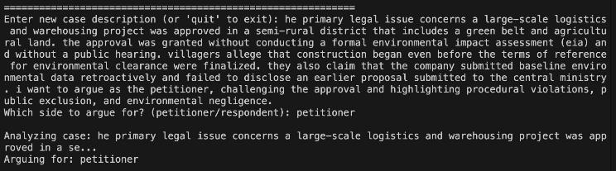
Fig2. Processing of Data

6.2 Advisory Report for Petitioner
Upon processing the input, the system generates an advisory opinion directed toward the petitioner (Fig. 2). This includes a concise summary of the case type, its implications, and the legal remedies typically sought.
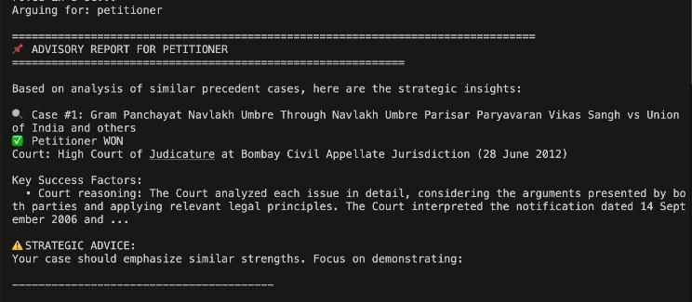
Fig 3. Summary of case type

6.3 Retrieval of Similar Case: Shri X vs. Y
The system then uses FAISS-based vector similarity search to identify relevant precedents from a legal corpus. In this example, the first retrieved case is "Shri X vs. Y", which closely matches the legal context of the input (Fig. 3).
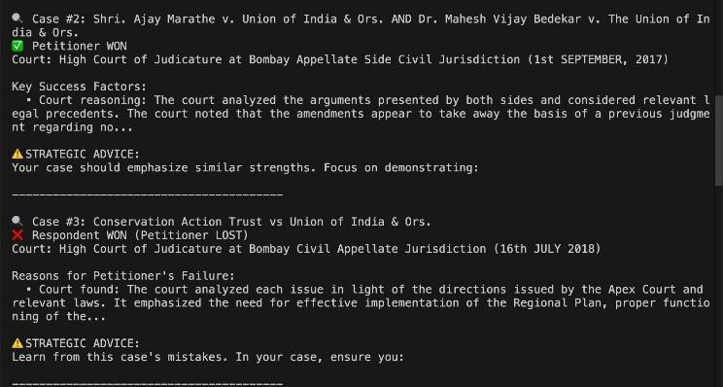
Fig 4.Strategic Advice with key factors

6.4 Strategy Generation
Based on the retrieved precedents, the AI generates a high-level litigation strategy. This includes suggested legal actions, potential arguments, and predicted judicial behavior (Fig. 4).
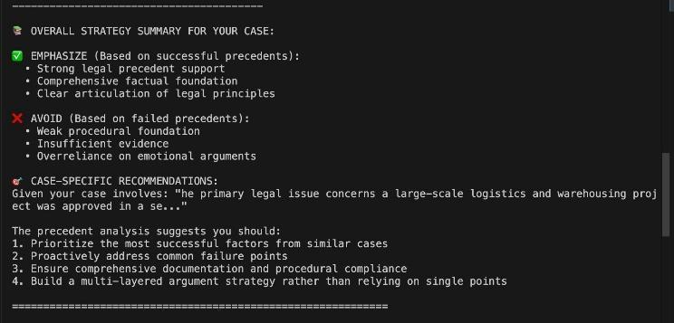
Fig 5. Overall strategy and case specific recommendation

6.5 Retrieval of Similar Cases
In addition to the primary match, the system retrieves multiple similar cases for reference. These are ranked based on cosine similarity with the input case description (Fig. 5).

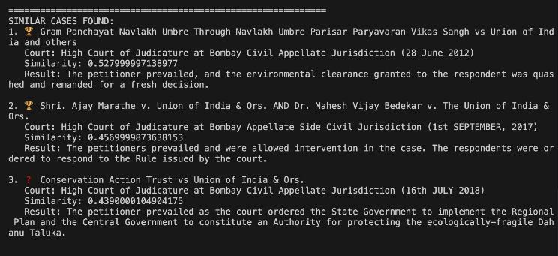
Fig 6. Similar cases in data

6.6 AI-Generated Legal Argument
The system then constructs a full-fledged legal argument to support the user’s position. This output includes logical flow, citations from past cases, and anticipatory rebuttals (Fig. 6).
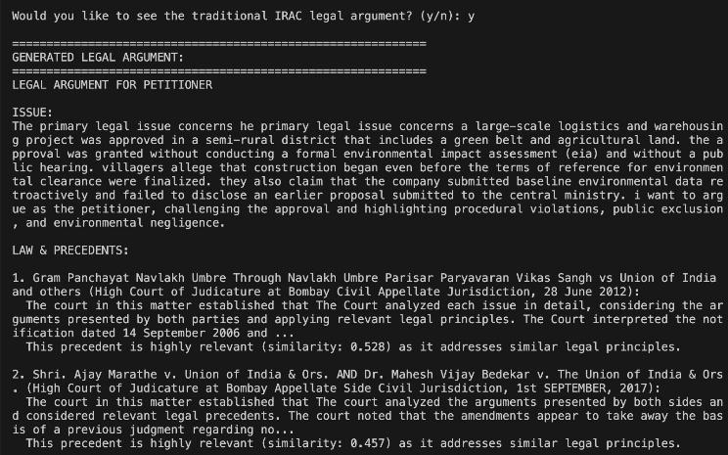
Fig 7. Logical AI generated legal argument

6.7 Case Reference: Conservation Action Trust
Among the results, the system recommends a landmark case — Conservation Action Trust vs. Union of India — as a highly relevant precedent (Fig. 7). This showcases the model’s ability to identify not only syntactic but also contextually significant cases.
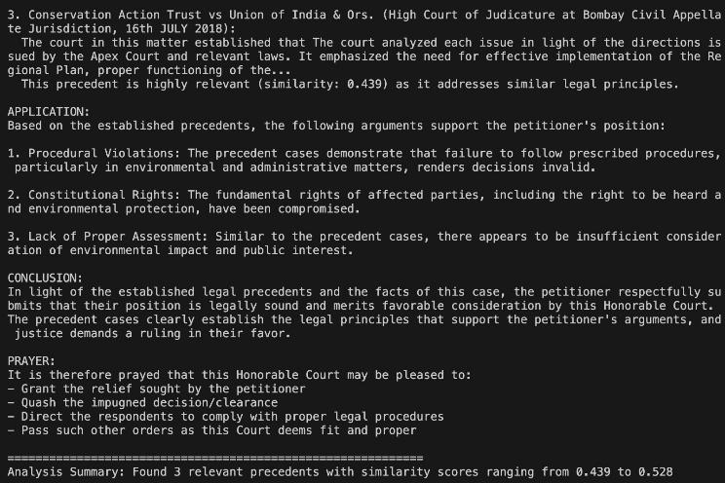
Fig 8. Significant cases
Together, these terminal outputs demonstrate the pipeline's ability to understand legal input, retrieve intelligent precedents, construct persuasive arguments, and recommend strategic actions — all in real-time and without human intervention
.
7. LIMITATION AND FUTURE SCOPE

7.1 Limitations
Although the AI-powered legal assistant presents a significant step forward in automating legal research and strategy development, it comes with several inherent limitations. The accuracy and quality of its outputs are closely tied to the size and diversity of the underlying legal corpus; in this implementation, the system was trained on a relatively limited dataset of Indian court judgments, which may lead to incomplete or less relevant recommendations. Additionally, since it relies on large language models like GPT, there is a risk of generating content that may be factually incorrect, biased, or speculative, potentially misrepresenting legal conclusions. Another concern is the absence of integration with real-time legal updates, which restricts the system from adapting to recent changes in laws or court decisions. Furthermore, the lack of jurisdictional awareness means it does not differentiate between legal precedents based on court hierarchy or geographical relevance, which can affect the reliability of its suggestions. Lastly, the tool is purely assistive and does not hold any legal authority or certification, meaning it cannot replace the role of a qualified legal professional.

7.2 Future Scope
To enhance the effectiveness and applicability of the system, several future improvements are envisioned. Incorporating real-time access to legal databases such as eCourts, SCC Online, or Indian Kanoon through official APIs would enable the assistant to stay updated with the latest court rulings and legal notifications. Introducing jurisdiction-aware retrieval by considering case type, court level, and geographic relevance would make the recommendations more contextually accurate. Expanding language support to include major Indian regional languages like Hindi, Marathi, and Tamil could significantly increase accessibility for a broader user base. Furthermore, the system has the potential to evolve into a comprehensive SaaS solution for legal professionals, offering features like collaborative case reviews, document storage, and personalized legal research workflows. Future versions could also incorporate adversarial case simulation, allowing users to explore legal arguments from both petitioner and respondent perspectives. Lastly, enhancing the system’s ability to explain its reasoning, supported by precise legal citations, would promote transparency and foster greater trust among its users.

8.CONCLUSION
The primary objective of this system was to support legal professionals by automating the retrieval of relevant case law and generating personalized legal strategies using AI. Focused on the Indian legal context, particularly Bombay High Court judgments, the system effectively extracts, structures, and semantically indexes legal data to enable fast and accurate precedent matching. By integrating vector-based case retrieval with GPT-powered strategic suggestions, the end-to-end pipeline—from user input to strategy output—operates reliably and validates the practical application of AI in legal workflows. The project demonstrates how a combination of LLMs and legal embeddings can enhance legal reasoning, reduce research time, and empower lawyers with actionable, context-aware insights, thereby bridging the gap between traditional legal research and intelligent automation.

Acknowledgment

The authors sincerely thank the Vishwakarma Institute of Technology, Pune, for providing the infrastructure and academic environment that made this research possible. Special gratitude is extended to our project mentor, Prof. Sagar Janokar, for his constant support, technical guidance, and invaluable feedback throughout the development of this system. We also acknowledge our peers and faculty members for their constructive suggestions and encouragement during the research phase.

References

- R. Sil, A. Alpana, and A. Roy, “A Review on Applications of Artificial Intelligence Over Indian Legal System,” IETE J. Res., vol. 69, no. 9, pp. 6029–6038, 2021.
- S. Chatterjee and N. S. Sreenivasulu, “Artificial Intelligence and Human Rights: A Comprehensive Study from Indian Legal and Policy Perspective,” Int. J. Law Manag., vol. 64, no. 1, pp. 110–134, 2022.
- A. Nair and N. Patil, “Challenges in Indian Legal Document Digitization,” Proc. ICAIL, 2021.
- P. Lewis, E. Perez, A. Piktus et al., “Retrieval-Augmented Generation for Knowledge-Intensive NLP Tasks,” in Proc. NeurIPS, 2020.
- I. Chalkidis, I. Androutsopoulos, and N. Aletras, “Legal-BERT: The Muppets Straight Out of Law School,” Findings of EMNLP, 2020.
- I. Chalkidis, M. Fergadiotis, and P. Malakasiotis, “CaseLawBERT: A Pretrained Language Model for Legal Text,” Findings of EMNLP, 2020.
- F. Rabelo, R. Goebel, and C. Longpre, “COLIEE: Competition on Legal Information Extraction and Entailment,” 2023. [Online]. Available: https://sites.ualberta.ca/~rabelo/COLIEE2023/
- T. Zhong, Z. Guo, and C. Zhang, “Legal Judgment Prediction via Legal Reading Comprehension,” in Proc. COLING, 2018.
- Y. Luo et al., “A Deep Learning Approach to Legal Judgment Prediction,” in Proc. ICAIL, 2017.
- D. Contreras et al., “LexNLP: Natural Language Processing for Legal Texts,” in Proc. ICAIL, 2018.
- R. Kalra, Z. Wu, and A. Gulley, “HyPA-RAG: A Hybrid Parameter Adaptive RAG System for Legal Reasoning,” arXiv preprint, Aug. 2024.
- M. Menon and A. Kapoor, “LawPal: A Conversational AI for Indian Legal Assistance,” Legal AI Workshop at EMNLP, 2023.
- T. Das and A. Ray, “LegalRAG: Multilingual Legal Document Retrieval with RAG Architecture,” Proc. NLP4Legal, 2023.
- Z. Zuo, X. Feng, and M. Huang, “Summarization of Legal Texts with Pretrained Transformers,” in Proc. NLPCC, 2021.
- J. Ju, “Enhancing Legal Retrieval with Poly-Vector Embeddings,” IEEE Trans. Knowl. Data Eng., vol. 35, no. 6, pp. 1243–1256, 2023.

